Exercise: Configure Robots in Orchestrator and run the jobs on Schedule timings

Steps:

1. Open Orchestrator by using specified URL (<https://demo.uipath.com> or <https://platform.uipath.com>)
2. Create the new Tenant user and become a tenant

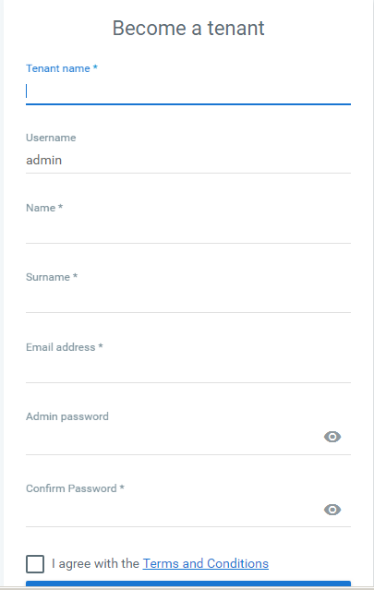

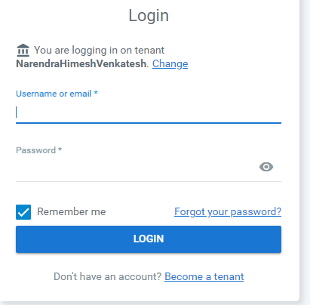

1. Login as a tenant user, after successfully creating

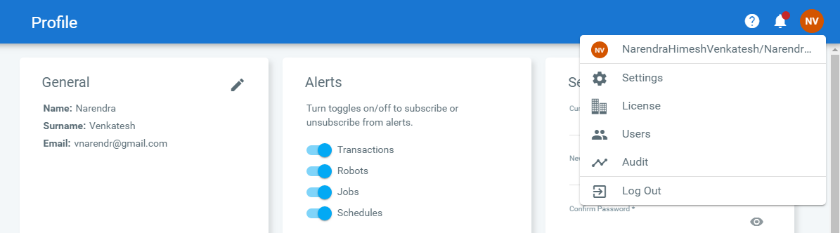

1. Orchestrator Dashboard is displayed

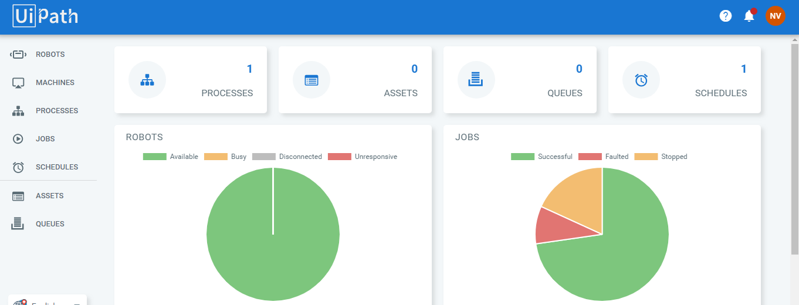

1. Create the Robot by click on Robots menu ->click Add button - >standard robot as showed in screen shot below

Note: Machine name and Domain name specified should be same as machine setting

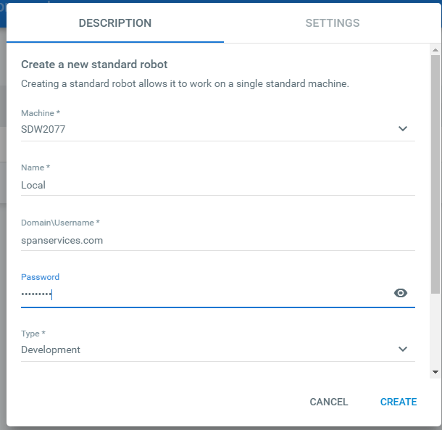



After creating the Robot

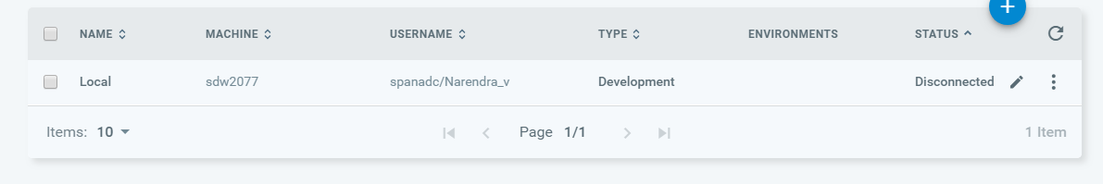

1. Create the Environment to run the robot

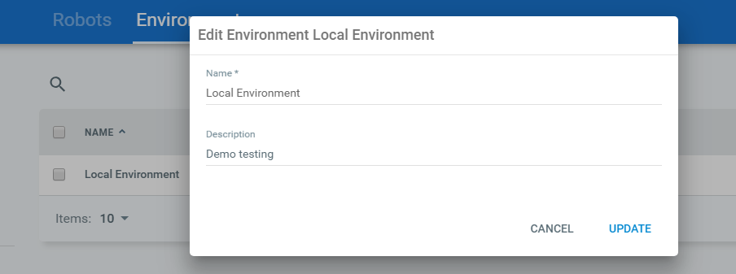

1. Access the Machine Key using Machine tabs -> View

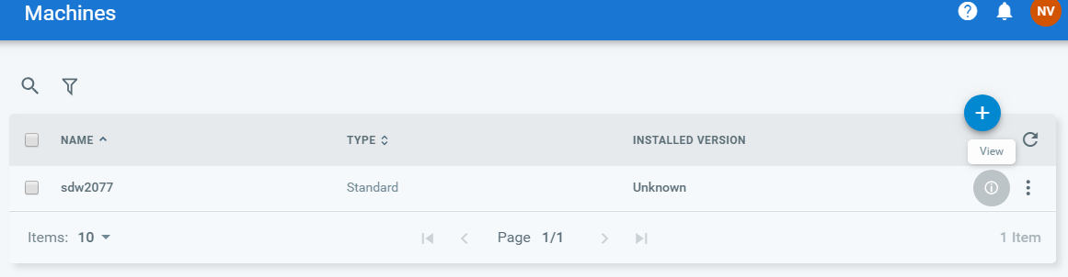

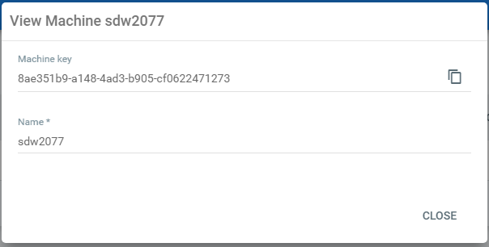

1. Connect Robot to Orchestrator using Machine key using setting in Robot.exe instance

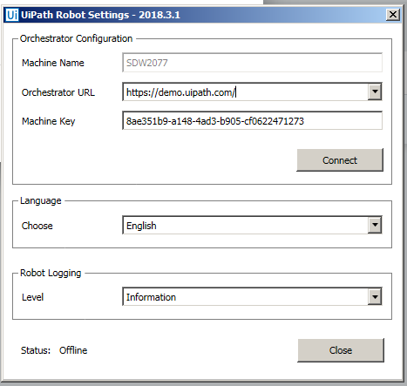

After successfully connected

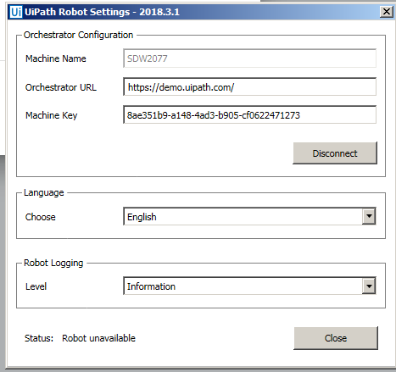

1. Publish the package to orchestrator using publish button in the ribbon menu bar

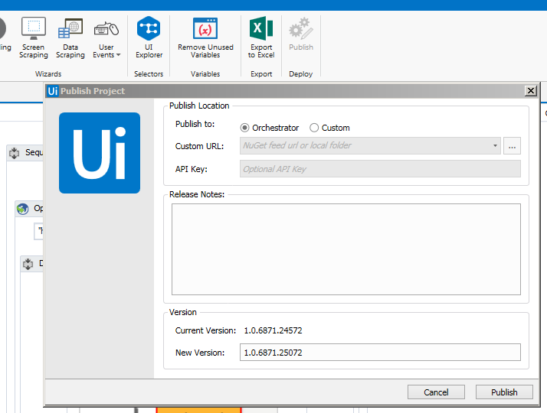

Note : If Specified domain is not correct , then UI-studio displays the below error message

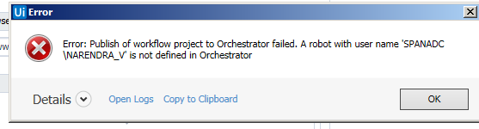

Else it will be published successfully

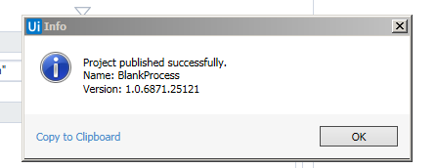

1. Once after successfully connected, status shows available in orchestrator and connected licensed in robot process

Note: Process will not be listed in Robot , if the environment is not set to robot (see below screen shot)

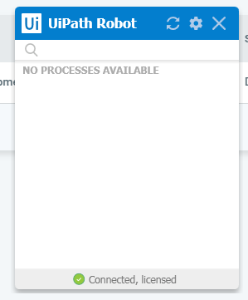

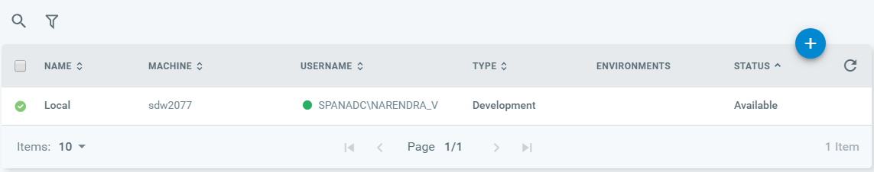

Will not list the process if the environment is not set or update see below screen shot

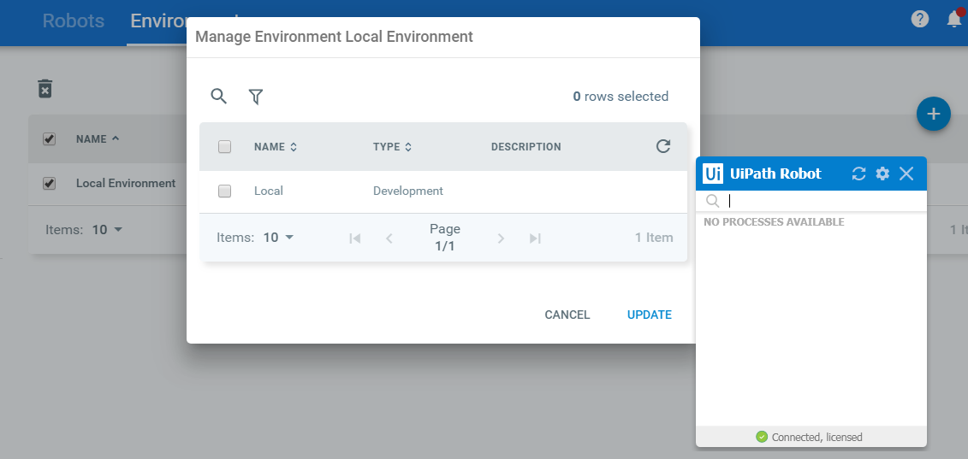

List out the process on update

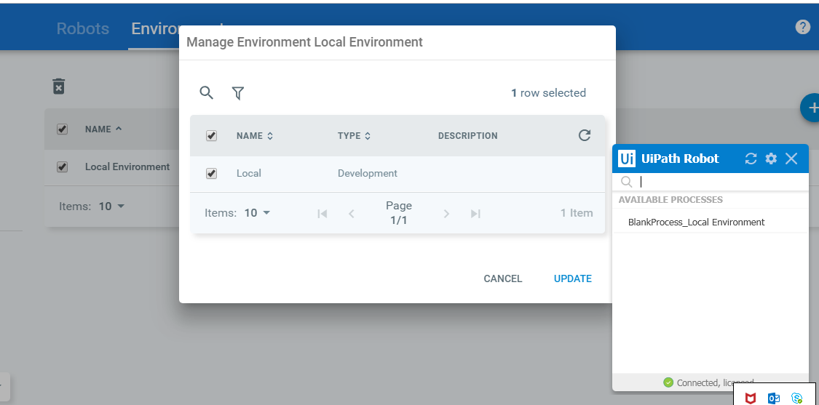

1. On successful publishing the project from UI Studio, package will be displayed in Package tab in Process Menu bar

Click on processes tab and select the deploy process (note version number is automatically populated)

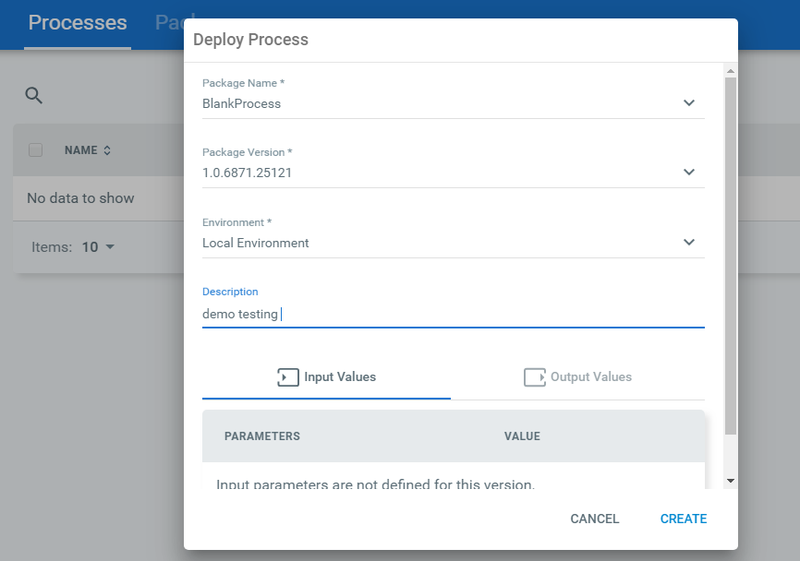

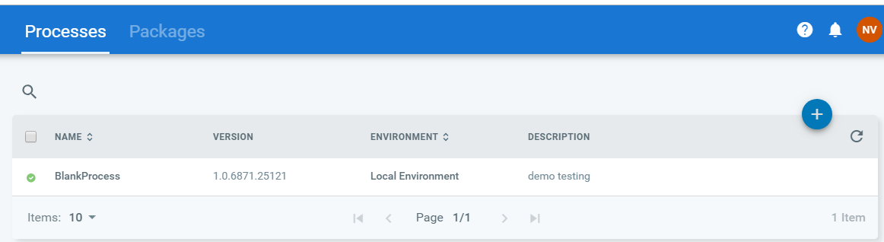

Packages list

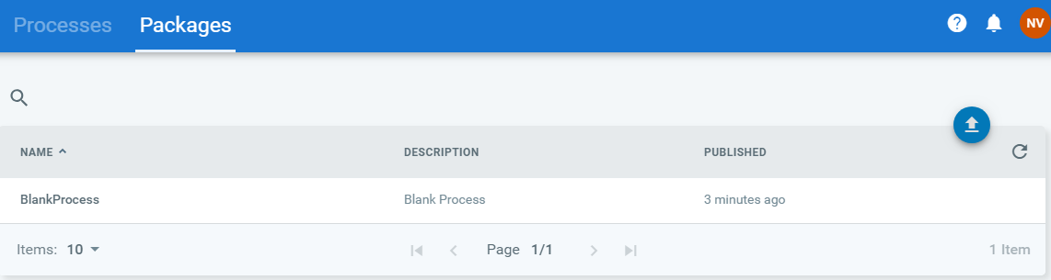

1. Create the Jobs -> click on run button -> select the process -> select the robot -> click on Start button (start button will be enabled only when specific robot is selected)

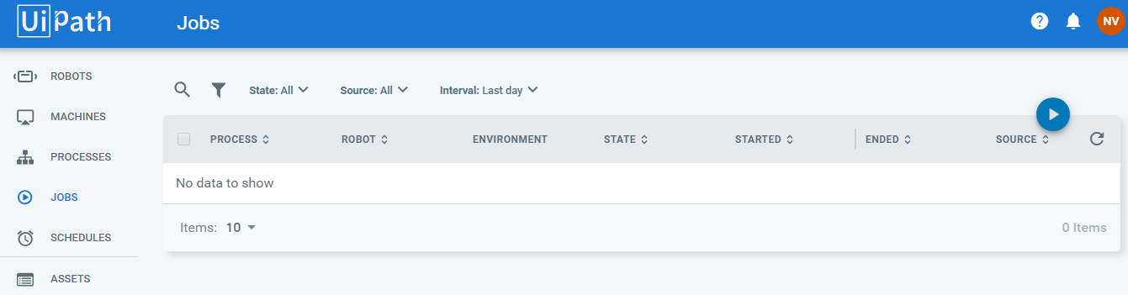

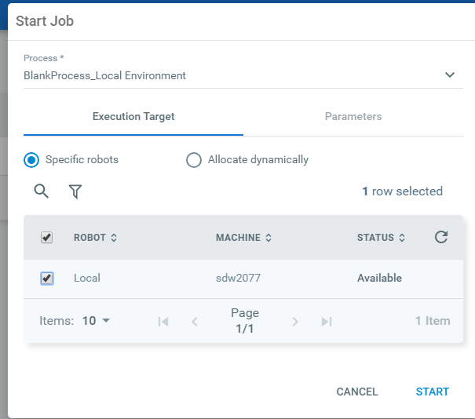

Select the process and click on run button -> this should execute the package and run the process (this should work like the script)

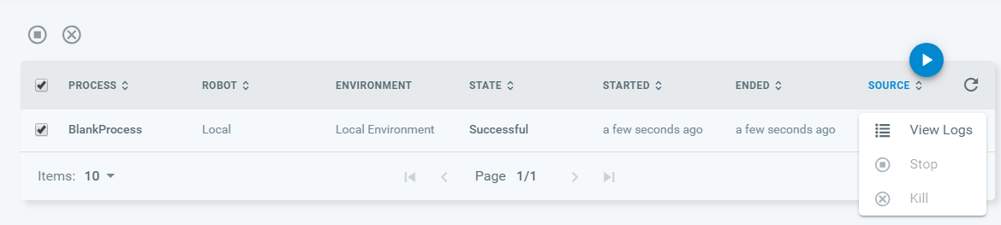

1. Schedule for created jobs - > click on Schedules menu -> click on Add button (+)-> specify the schedule name ->along with other details -> click on Update

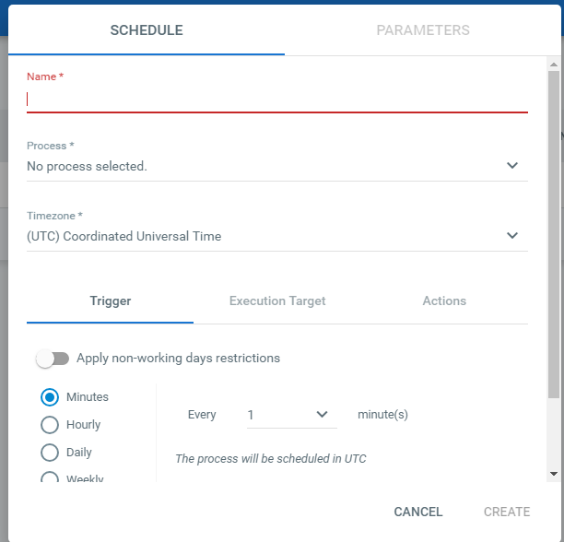

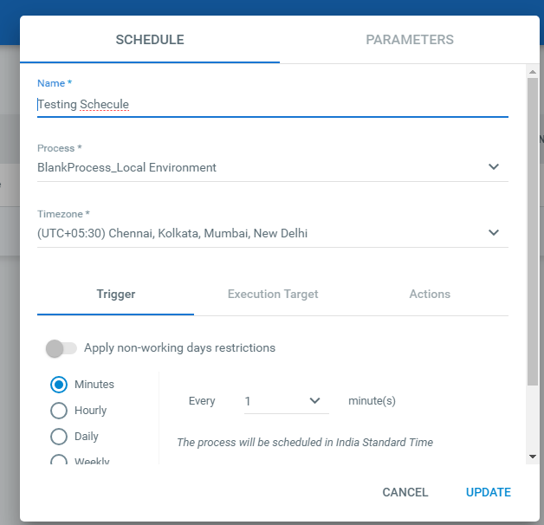

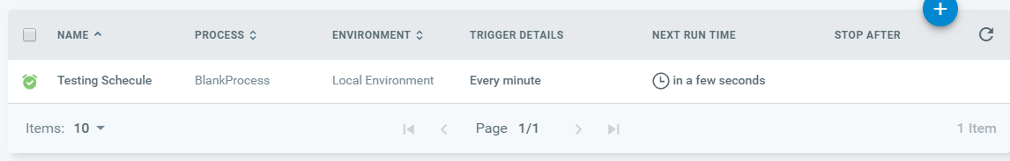

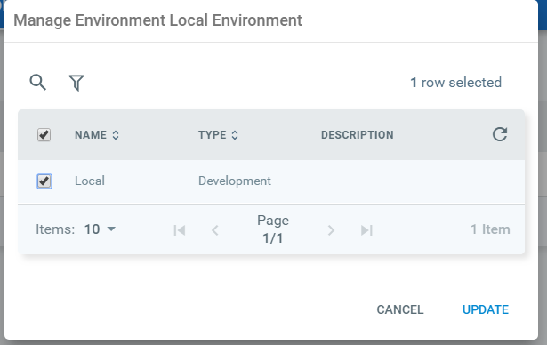

On Click of Start job execute it successful and status is shown below

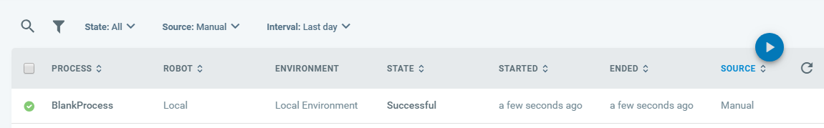

Enable or disable the scheduler by view option

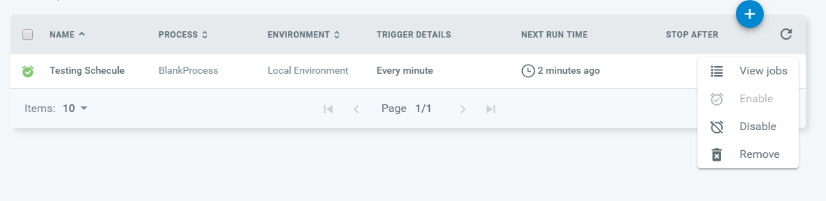

Navigate to View process -> version Management -> use (will update the selected package)

